***CLINICAL MICRO PCT 100- Regular batch***

1. Louis Pasteur is associated with all except.
2. Solid culture media
3. Germ theory
4. Pasteurisation
5. Vaccination of rabies
6. Which event takes place lag phase of growth curve.
7. Bacterial cell no increase
8. Bacterial cell size increase
9. Sporulation
10. Active metabolism
11. Disposable glass syringes are best sterilised by.
12. Autoclave
13. Hot air oven
14. ETO
15. Glutaraldehyde
16. Best method of sera sterilisation is.
17. Filtration
18. Autoclaving
19. Radiation
20. Heating
21. Spore of which bacteria is used as sterilisation control of plasma sterilisation.
22. B. subtilis
23. B. pumilis
24. Cl. Tetani
25. B. stearothermophilus
26. CLED medium is used in preference to Mc conkey agar in relation to culture of organism involved in urine infection. The reason is.
27. It prevents swarming of proteus
28. Differentiates LF & NLF
29. Promotes staphylococcus, streptococcus & candida
30. Identifies pseudomonas
31. Triple sugar iron test detects all the following properties except.
32. Gas
33. H2S
34. Sugar fermentation
35. Citrate utilisation
36. Recommended transport medium for stool suspected to contain enteric pathogens.
37. Pikes
38. Amies
39. Stuarts
40. Buffered glycerol saline
41. Which of the following transmits resistance in bacteria.
42. Transposon
43. Plasmid
44. Mitochondria
45. Cellwall
46. Identify the following image.
47. Ignaz semmelweis
48. Louis Pasteur
49. Paul Ehrlich
50. Robert Koch



1. There is outbreak of infection with staphylococcus in a burn ward. Best site to take a swab.
2. Nasopharynx
3. Oral cavity
4. Nose
5. Conjunctiva
6. Most common cause of native valve endocarditis.
7. Staphylococcus aureus
8. Staphylococcus epidermidis
9. Streptococcus viridans
10. Enterococcus
11. Bacitracin sensitivity is used to differentiate.
12. Group A streptococcus from staphylococcus
13. Group A streptococcus from other Beta hemolytic streptococci
14. Group A streptococcus from Gamma hemolytic streptococci
15. Group A streptococcus from Alpha hemolytic streptococci

1. Streptococcal skin disease is diagnosed by antibody against.
2. DNAase A
3. DNAase B
4. DNAase C
5. DNAase D
6. The following are features of pneumococcus except.
7. Bile insolubility
8. Optochin sensitivity
9. Gram positive
10. Encapsulated
11. Presumptive diagnosis of meningococcal meningitis is made earliest by.
12. CSF culture
13. PCR
14. LAT
15. CFT
16. Diphtheria toxin acts by.
17. Inhibiting acetyl choline release
18. Inhibiting GABA
19. Increasing levels of Camp
20. Inhibiting protein synthesis
21. A child came with fever, cold, cough, membrane over tonsils. Nasal swab is taken, culture should be done on which medium for earliest diagnosis.
22. Lofflers serum slope
23. LJ media
24. Mc conckey agar
25. PTBA
26. Swarming growth on culture is characteristic of which gram positive organism.
27. Proteus mirabilis
28. Cl. Tetani
29. Cl. welchii
30. Vibrio parahemolyticus
31. Among the toxin produced by cl.botulinum, the non-neurotoxic one is.
32. A
33. B
34. C1
35. C2
36. Botulism is most commonly due to.
37. Egg
38. Milk
39. Meat
40. Pulses
41. Fish tank granuloma is seen in.
42. M. ulcerans
43. M. kansassi
44. M. marinum
45. M. leprosy
46. Dienes’ phenomena is seen with.
47. Mycoplasma
48. Proteus mirabilis
49. Providentia
50. Morganella
51. The following are gas producing salmonella except.
52. S. typhi
53. S. gallinorum
54. S. Paratyphi A
55. S. typhimurium
56. Clinical significance of Vi antigen of S typhi is.
57. Helps in diagnosis
58. Highly immunogenic
59. Most important antigen for widal test
60. Antibody against Vi-antigen is used for diagnosis of carrier
61. Kanagawa’s phenomenon is seen in.
62. Pseudomonas aeruginosa
63. Vibrio parahemolyticus
64. Burkholderia Pseudomallei
65. Proteus mirabilis
66. Skirrow’s medium is used for.
67. Clostridium tetani
68. Corynebacterium diphtheria
69. Campylobacter jejuni
70. Chlamydia trachomatis
71. Bacteria that can grow even in the presence of antiseptic.
72. Staphylococcus
73. Streptococcus
74. E. coli
75. Pseudomonas
76. Which of the following is non- motile.
77. Pseudomonas aeruginosa
78. Burkholderia pseudomallei
79. Burkholderia mallei
80. Stenotrophomonas maltophila
81. Best culture for primary isolation of H. influenzae.
82. Blood agar
83. Fildes agar
84. Bordet Genguo medium
85. Trypticase soy agar
86. A farmer who handles goats and sheep is presenting with fever, Hepatosplenomegaly, muscle and joint pain, and rash. The most likely diagnosis is.
87. Leptospirosis
88. Brucellosis
89. Glanders
90. Meliodosis
91. Most effective test for prognosis of syphilis is.
92. VDRL
93. FTA-ABS
94. TPHA
95. TPPA
96. Patient came from Nagaland and shows positive test with OXK antigen.
97. Trench fever
98. Scrub typhus
99. Endemic typhus
100. Epidemic typhus
101. Which is not transmitted by arthropod.
102. Orientia tsutsugumushi
103. Coxiella burnetii
104. Rickettsia akari
105. Rickettsia rickettsiae
106. Identify the following image.
107. M.Tuberculosis
108. M.Leprosy
109. Nocardia
110. cyclospora

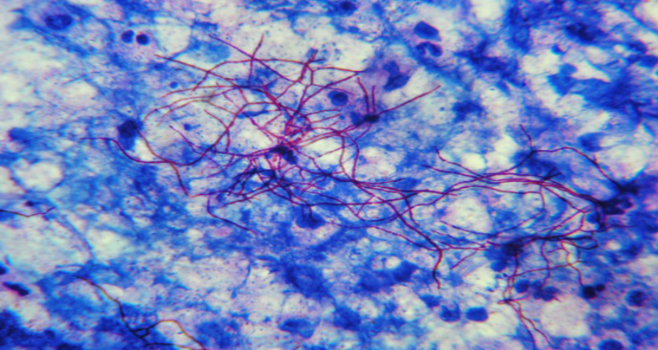

1. Components of innate immunity.
2. T lymphocytes
3. B lymphocytes
4. Complements
5. Antibody
6. Innate immunity active against viral cells.
7. NK cells
8. Plasma cells
9. B cells
10. Memory B cell
11. Heterophile antibody is found in.
12. Weil felix
13. Widal
14. Standard agglutination test
15. All
16. Papain cleaves the Ig into.
17. 1 Fc & 1 Fab
18. 1Fc & 2 Fab
19. 2 Fc & 1 Fab
20. 2 Fc & 2 Fab
21. Rheumatoid arthriris is best diagnosed by.
22. RA factor
23. Anticitrulline Ab
24. IgM
25. IgG
26. Intestinal immunity is due to which Ig.
27. IgM
28. IgG
29. IgA
30. IgE
31. The Ig which activates alternate complement pathway.
32. IgG
33. IgE
34. IgA
35. IgM
36. Immunoglobulin that is elevated in helminthic infection.
37. IgG
38. IgA
39. IgM
40. IgE
41. IgE is secreted by.
42. Mast cell
43. Basophil
44. Eosinophils
45. Plasma cells
46. Vaccine contraindicated in HIV
47. Varicella
48. IPV
49. Hib
50. DPT
51. Minimum gap between two live vaccines is.
52. 1 week
53. 2 weeks
54. 3 weeks
55. 4 weeks
56. Mutation associated with Wiskott Aldrich syndrome.
57. Y chromosome
58. Chromosome 11p22
59. Chromosome 22q11
60. X chromosome
61. Chronic granulomatous disorder is due to defect in.
62. B-cell
63. NADPH oxidase
64. IgA
65. T-cell
66. Purine Nucleoside phosphorylase deficiency.
67. Humoral immunity deficiency
68. Acquired immunity deficiency
69. SCIDs
70. Cell mediated immunity deficiency
71. Adenosine deaminase deficiency is seen in the following.
72. Common variable immunodeficiency
73. Severe combined immunodeficiency
74. Chronic granulomatous disease
75. Nezel of syndrome
76. Autoinfection is seen in all except.
77. Strongyloides
78. Taenia solium
79. Hymenolepis nana
80. Trichuris Trichura
81. Which among the following does not enter human body via skin
82. Ancyclostoma
83. Strongyloides
84. Trichinella
85. Necator
86. Fish acts as an intermediate host in.
87. D. medinensis
88. Clonorchis sinensis
89. strongyloides
90. H. nana
91. Patient presents with diarrhoea, associated with blood, stool, mucous and fever. What is your likely diagnosis.
92. Giardia lamblia
93. E. histolytica
94. Salmonella Typhi
95. Isospora species
96. Treatment given to Entamoeba cyst carriers is.
97. Metronidazole
98. Paromomycin
99. Diloxanide furoate
100. Iodoquinol
101. Girl visits her friend’s village, develops nasal discharge, meningitis and dies in 5 days. Organism responsible is.
102. Naegleria fowleri
103. Acanthamoeba
104. Balamuthia
105. Sappinia
106. A pt. presented with features of acute meningoencephalitis in the casualty. CSF on wet mount microscopy revealed motile unicellular microorganism.
107. Naegleria fowleri
108. Acanthamoeba castellani
109. Entamoeba histolytica
110. Neurocysticercosis
111. All are true about Chagas’ disease except:
112. Romana’s sign is a diagnostic feature of acute Chaga’s disease
113. Tsetse fly is the vector
114. Cultured in NNN medium
115. Has amastigote and trypomastigote forms
116. Espundia is a condition seen in:
117. Endemic syphilis
118. Cerebral Malaria
119. Lympho Granuloma Venereum
120. Mucocutaneous leishmaniasis
121. Orally effective drug approved for Leishmaniasis:
122. Paromomycin
123. Pentamidine
124. Stimaquine
125. Miltefosine
126. Why are schizont and late trophozoite stages of Plasmodium falciparum not seen in peripheral blood smear?
127. They are sequestered in the spleen
128. Due to adherence to the capillary endothelium, they are not seen in peripheral blood
129. Due to antigen-antibody reaction and removal, antibody dependent cytotoxic killing
130. They are seen in mosquito blood
131. Which type of malaria is associated with renal failure & nephrotic syndrome?
132. Falciparum
133. Vivax
134. Malariae
135. Ovale
136. Dye test is used in the diagnosis of:
137. Leishmaniasis
138. Trypanosomiasis
139. Toxoplasmosis
140. Amoebiasis
141. Toxoplasmosis in the fetus can be best confirmed by:
142. IgM antibodies against Toxoplasma in the mother
143. IgM antibodies against Toxoplasma in the fetus
144. IgG antibodies against Toxoplasma in the mother
145. IgG antibodies against Toxoplasma in the fetus
146. Congenital toxoplasmosis false is,
147. IgA is better than IgM in detection
148. Diagnosed by detection of IgM in cord blood
149. Dye test is gold standard and it detects IgG
150. Avidity test must be done to differentiate IgA and IgM
151. Unsheathed microfilaria is seen in.
152. W. bancrofti
153. B. malayi
154. Loa loa
155. O.volvulus
156. Ova in stool are not of diagnostic significance in.
157. Strongyloides
158. Enterobius
159. Ancylostoma
160. Trichuris
161. Which of the following parasites life cycle is shown below.

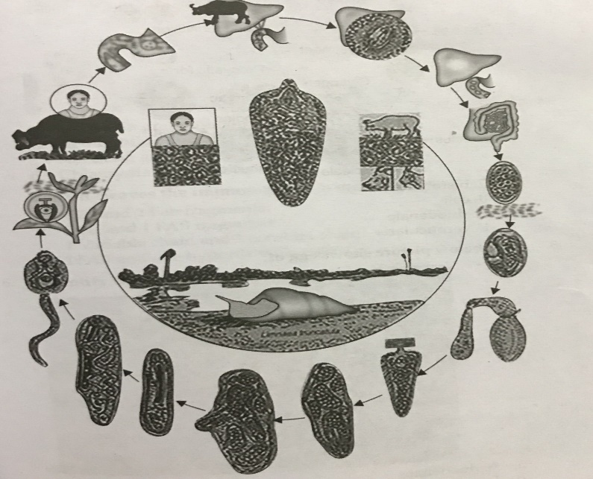

1. Fasciola hepatica
2. Fasciola buski
3. Chlonarchis sinensis
4. P. westermani
5. The below pic shows egg of.
6. A. duodenale
7. E. vermicularis
8. A. lumbricoides
9. S. stercoralis

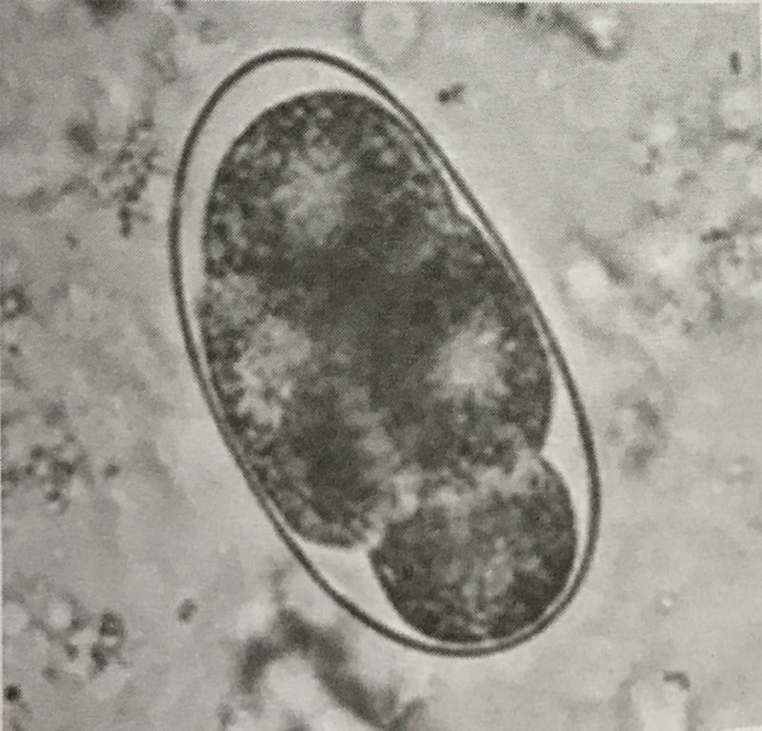

1. Tinea cruris is caused by.
2. T. rubrum
3. M. Canis
4. T. verrucosum
5. T. tonsurans
6. A gardener has multiple vesicles on hand and multiple eruptions along the lymphatics. Most common fungus responsible is?
7. Sporothrix schenckii
8. Cladosporium
9. Histoplasma
10. Candida
11. Sclerotic bodies are seen.
12. Sporotrichosis
13. Chromoblastomycosis
14. Coccidiomycosis
15. Pneumocystis pneumonia
16. Reynold Braude phenomenon is seen in.
17. Candida albicans
18. Candida tropicalis
19. Candida glabarata
20. Candida auris
21. A vitreous aspirate from a case of metastatic endophthalmitis on culture yields Gram-positive round to oval cells, 12-14 m in size. The aspirate on Gram staining shows the presence of pseudohyphae. Which of the following is the most likely aetiological agent?
22. Aspergillus
23. Rhizopus
24. Candida
25. Fusarium
26. An elderly diabetic has left sided orbital cellulites, CT scan of paranasal sinuses shows evidence of left maxillary sinusitis. Gram stained smear of the orbital exudates shows irregularly branching septate hyphae. The following is the most likely aetiological agent
27. Aspergillus
28. Rhizopus
29. Mucor
30. Candida
31. 1, 3-beta D-glucan assay can identify all the following organisms except.
32. Invasive aspergillosis
33. Pneumocystis jiroveci pneumonia
34. Invasive candidiasis
35. Invasive cryptococcosis
36. The organism shown below is.
37. Aspergillus
38. Candida
39. Histoplasma
40. Paracoccoidiomycosis

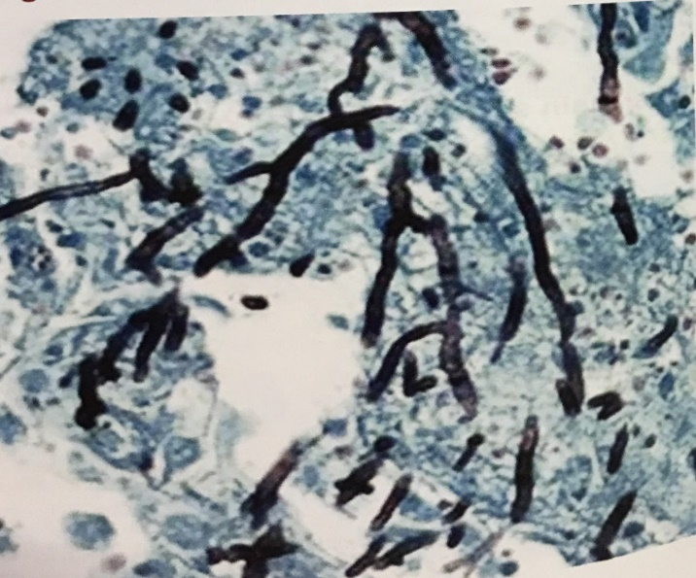

1. A farmer residing, developed a verrucous lesion following the thorn prick injury. HPE of the lesion showed the following.
2. Sporotrichosis
3. Chromoblastomycosis
4. Brucellosis
5. Actinomycosis

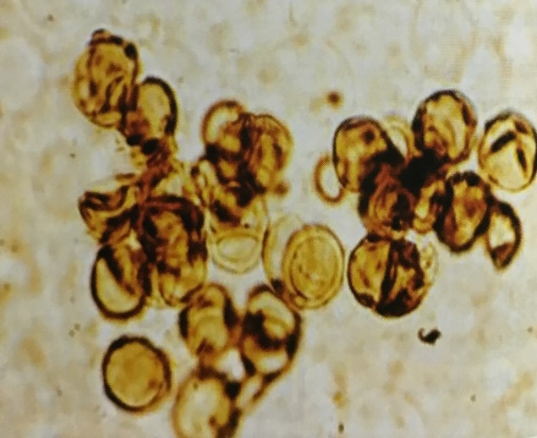

1. HIV patient presented with fever & diarrhoea for weeks. Patient was started on COTRIMOXAZOLE. Diarrhoea responded but continued to have fever. Bonemarrow aspirate showed the following picture. What is the organism
2. It is an intracellular yeast
3. Does not grow on SDA
4. It can cause disseminated infection
5. Intestinal sporozoa

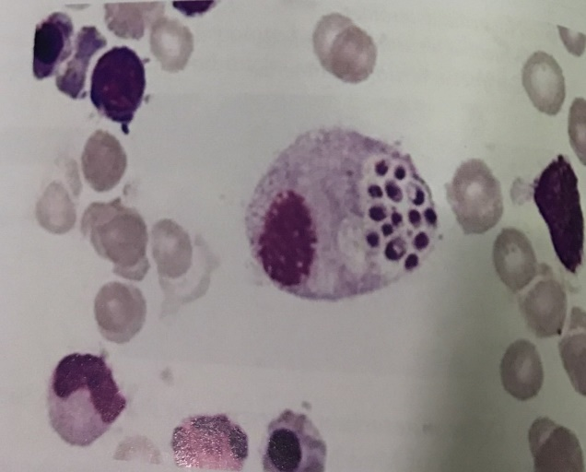

1. Virus quantification is done by.
2. Quantal assay
3. Hemadsorption
4. Plaque assay
5. Electron microscopy
6. True about interferon is.
7. Host specific
8. Viral specific
9. Inactivated by nucleases
10. Virus protein
11. Which of the following is a primary cell line.
12. Chick embryo fibroblast
13. WI-38
14. HeLa cells
15. Vero cells
16. Which of the following is not an RNA virus.
17. Ebola
18. SV 40
19. Rabies
20. Vesicular stomatitis virus
21. All of the following vaccines are developed from embryonated eggs except.
22. Influenza
23. Rabies
24. Yellow fever
25. CMV
26. The following is not a live vaccine.
27. Measles
28. BCG
29. Yellow fever
30. Salk’s vaccine
31. INF gamma secreted by.
32. Activated T cell
33. CD 8 cell
34. RBC
35. Neutrophils
36. segmented genome is found in all except.
37. Influenza
38. Arena
39. Bunya
40. Rhabdo
41. Serological test of a pt. shows HBsAg negative, IgM Anti HBC Ab negative, HBV DNA not detectable, Anti HBC IgG Ab positive & Anti HBsAg Ab positive. Diagnosis is
42. Acute hepatitis window period
43. Chronic hepatitis in active stage
44. Chronic hepatitis with precore mutant
45. Recovery from the infection of Hepatitis B
46. Shingles is caused by.
47. HSV 1
48. HSV 2
49. HHV 3
50. HHV 4
51. A neonate has HSM. His urine was stained with Giemsa stain which revealed owls eye appearance inclusions.
52. CMV
53. HIV
54. Rubella
55. EBV
56. Which of the following is a rec for EBV.
57. CR1
58. CR2
59. CR3
60. CR4
61. PML is caused by.
62. CMV
63. EBV
64. JC
65. RSV
66. Resistance to HIV infection occurs due to mutation of.
67. CCR 5
68. CXCR4
69. CD4
70. gp120
71. All the diseases transmitted by Culex , except?
72. JE
73. Chikungunya fever
74. West Nile fever
75. Filariasis
76. Acute hemorrhagic conjunctivitis is caused by enterovirus:
77. 68
78. 69
79. 70
80. 71
81. Herpangina is caused by:
82. Enterovirus
83. Rhinoviruses
84. Myxovirus
85. Rabies virus
86. Infantile pericarditis and myocarditis is caused by
87. Coxsackie B
88. Coxsackie A
89. Polio
90. Eneterovirus 70
91. True about antigenic drift
92. Caused only by influenza A
93. Leads to seasonal epidemics
94. Leads to pandemic
95. Arises due to frameshift mutations
96. The following disease is caused by.
97. Coxsackie
98. Parvo
99. Paramyxo
100. Herpes

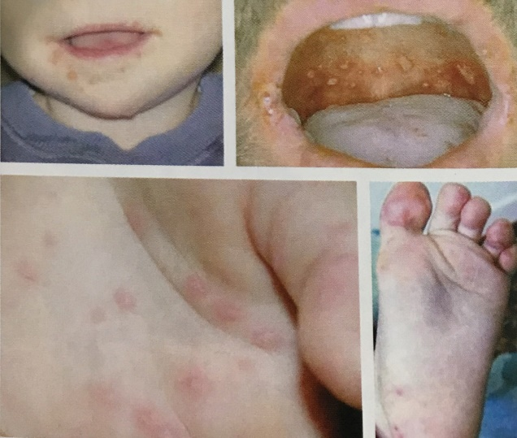

1. The following picture depicts which virus.
2. HBV
3. HPV
4. HSV
5. HIV

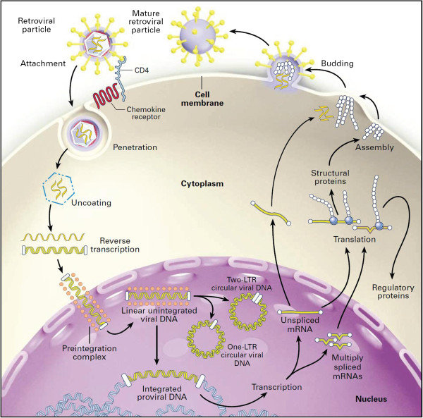

**Answer Key:**

|  |  |  |  |  |
| --- | --- | --- | --- | --- |
| 1. a | 11.c | 21.c | 31.b | 41.c |
| 2. b | 12.a | 22.c | 32.a | 42.c |
| 3. b | 13.b | 23.b | 33.b | 43.d |
| 4. a | 14.b | 24.a | 34.b | 44.d |
| 5. d | 15.a | 25.d | 35.c | 45.a |
| 6. c | 16.c | 26.b | 36.c | 46.d |
| 7. d | 17.d | 27.c | 37.a | 47.d |
| 8. d | 18.a | 28.d | 38.a | 48.b |
| 9. b | 19.b | 29.c | 39.b | 49.d |
| 10. c | 20.d | 30.b | 40.b | 50.b |

|  |  |  |  |  |
| --- | --- | --- | --- | --- |
| 51. d | 61.b | 71.a | 81.a | 91.b |
| 52. c | 62.c | 72.b | 82.a | 92.c |
| 53. b | 63.c | 73.a | 83.b | 93.a |
| 54. b | 64.b | 74.c | 84.d | 94.b |
| 55. b | 65.d | 75.a | 85.d | 95.c |
| 56. a | 66.d | 76.d | 86.a | 96.a |
| 57. a | 67.a | 77.a | 87.d | 97.a |
| 58. b | 68.a | 78.b | 88.d | 98.b |
| 59. d | 69.a | 79.a | 89.c | 99.a |
| 60. d | 70.a | 80.c | 90.a | 100.d |